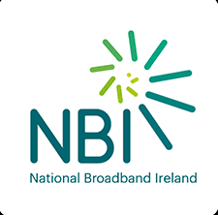

White Label Broadband
Reliable, scalable and affordable internet service throughout Ireland

Definition
The Enet White Label Broadband product enables RSPs to develop their SME and Retail market by allowing them to self-brand Enet’s end-to-end Broadband solution to their customers. White Label Broadband is a Layer 3 internet service provided by Enet through our Aggregation Platform (known as Enet Connect). This provides access to several Access Service Provider (ASP) networks to ensure maximum geographic penetration and potential customer access.
The RSP can offer their customers a range of different broadband speeds to suit their End-Users’ needs.

Service Description

White Label Broadband is a comprehensive Layer 3 end-to-end broadband solution and includes the following key elements:
- FTTx Access: FTTC or FTTH access for the last mile to the End-User premises
- Enet Interconnect: Availing of Enet’s interconnects to the ASPs
- Enet Backhaul: Using Enet’s backhaul to get from the interconnects to the Enet Edge Routers
- Enet ISP: Accessing the Internet via Enet Edge and ISP Gateways
This is a stand-alone service, with broadband only, and by default excludes a Voice Service. To facilitate an effective self-branded solution, the RSP is responsible for managing all aspects of the End-User delivery beyond the ONT/NTU-MasterSocket. This includes in-home equipment (CPE, RGW, modems), connection to and all cabling and equipment beyond the ONT / NTU-MasterSocket.
The main features include:
- Bandwidths: Asymmetric 150Mb to 1Gb downstream for Fibre, up to 100Mb downstream for FTTC (VDSL)
- End-user Traffic will utilise the Enet Network
- Traffic handoff: Enet manages the provision and delivery of an internet service for the RSP
- S-VLAN numbers are managed by Enet and are not visible to the RSP
- Network Security: IPoE [DHCP] only, Anti-MAC and Anti-IP Spoofing
- RADIUS and IPAM services are provided by Enet

An RSP can fully self-serve by using Enet Connect to perform the following key functions:
- Address Search Facility
- Eligibility requests that query all ASPs and return a suitable set of products
- Ordering and Order Management
- Fault Handling
- Diagnostics etc.

Summary

 | FTTH | FTTC
Bandwidth | Asymmetrical 1Gb, 500Mb, 150Mb products | “Up to 100mb” Rate Adaptive Asymmetrical products
Access Network Technology | PON | VDSL2
Splitter | Splitter: 1:32 (1:64 open eir IFN) | n/a: DSLAM
Enet Access demarcation | RJ45 Ethernet interface on an ONT for FTTH | RJ45 Copper NTU/Master Socket demarcation for FTTC
Maximum MTU | 1950 (SIRO, open eir & NBI) | 1500 (open eir)
ONT/NTU installation by Access Provider | Yes (ONT) | Yes (NTU-Master Socket)
Subscriber Identification | Performed on Enet Radius using DHCP/IPoE
N:1 or 1:1 service? | N:1
Max. no. of MAC Addresses | 1
VLAN ID tagging | The End-User CPE, provided and managed by the RSP, must be configured to  tag all traffic with VLAN ID 10 irrespective of the underlying ASP (the default on an unconfigured modem is Vlan 10)
 | End-User CPE must also be configured with DHCP Enabled
Connectivity | Single Unicast as standard and mandatory with Unicast bandwidth,  downstream and upstream
Class of Service 802.1p | Default is Best Efforts “0”
Modem / RGW supplied by RSP | Yes
IP Addresses | Provided by the RSP by default or by Enet if required

Service Delivery

Partnering with Enet permits an RSP access to our Broadband Aggregation Portfolio which provides:
- Access to the open eir (1.8m), SIRO (400k+) and NBI (Target 450k+) FTTx networks through a single integration point
- Reduced integration time and speed to market
- A common ordering and fault process irrespective of the FTTx access provider
FTTH: the access service is from the ONT at the End-User premises via fibre to a splitter in the access network and on to an OLT (remote or at a Colo).
FTTC: the access service is from the NTU-Master socket at the End-User premises via a copper pair to the cabinet DSLAM. Here services are aggregated before connecting to the local Colo via fibre.
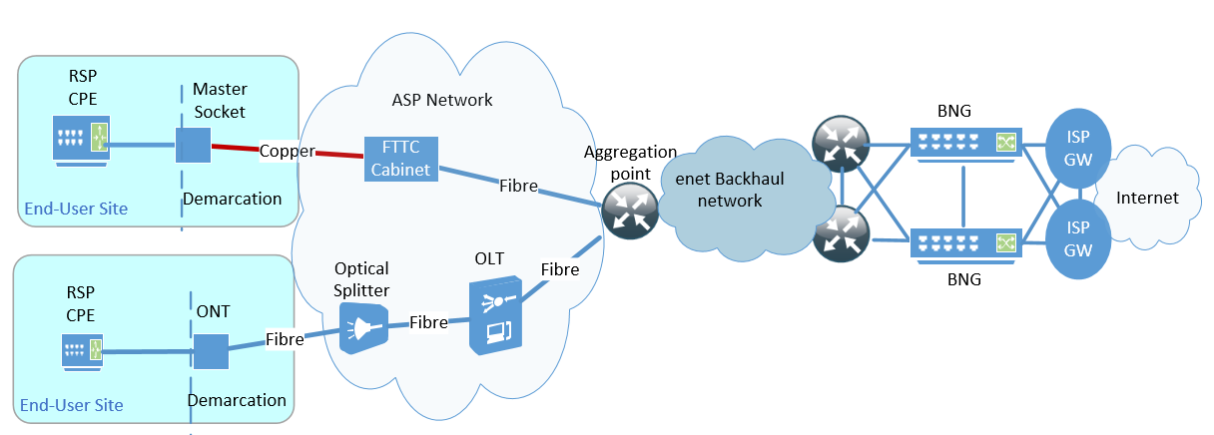

Enet Responsibilities
Enet is responsible for:
- Building links from our ASP partners’ local (c.200) aggregation points to enable RSPs to access the service
- Guiding and assisting RSPs during the Onboarding process (including the Enet Connect platform)
- Assisting RSP queries with our Order Support team
- Ensuring the RSP has access to the Enet Connect platform including process and Train-the-Trainer sessions
- Working with our ASP partners to ensure service provision from the End-User’s premises
- The operation and maintenance of the broadband service including RADIUS and IPAM
- Effective Service Assurance through our NOC and Support Team

RSP Responsibilities
The RSP is responsible for:
- Supporting effective Onboarding by providing relevant points of contact
- Completing the VPN set up to ensure access to Enet Connect
- Performing eligibility checks to determine service capability
- Manage the Order in delivery including appointment reschedules (all via Enet Connect)
- Providing the CPE for the End-User
- Owning the relationship with the End-User including change orders, fault handling etc.
- Acting as the first point-of-contact for any End-User enquiries

Glossary
- ASP Alternative Service Provider
- BNG Border Network Gateway
- COS Class of Service
- EVPL Ethernet Virtual Private Line
- IPAM IP Address Management
- IFN Ireland’s Fibre Network
- ISP Internet Service Provider
- MAC Media Access Control
- MTU Maximum Transmission Unit
- NBI National Broadband Ireland
- NTU Network Terminating Unit
- OLT Optical Line Terminal
- ONT Optical Network Termination
- RGW Retail GateWay / Residential GateWay
- S-VLAN Service-Virtual Local Area Network
- VOIP Voice Over IP

Further Information
Contact your Enet Account Manager or contact us at:
Telephone: + 353 (0)61 274000
Webpage: www.Enet.ie

